

**Programming Applications and Frameworks**

3rd Year, 1st Semester

Group assignment feedback report

**Project ID - Group S1.01.1.**

**LAB 601**

**Online Channeling System**

|  |  |  |
| --- | --- | --- |
| Student No | Name | Services |
| IT18108514 | Wanigasekara M.P.W..P.A | Admin service |
| IT18076080 | A.vethakulan | Payment service |
| IT18014914 | Jude Ashan Lakmal M.A | Appointment service |
| IT18135794 | De silva L.H.C.R | Doctor service |
| IT18194272 | Jinadasa M.W. | Patient service |

**Table of Contents Page No**

1. **Description of web services……………………………………………………3-4**
2. **Workload Allocation5**
3. **API designs for service…………………………………………………………….6-8**

4. Appendix

Appendix 1: ER Diagram9

Appendix 2: Schema for ER diagram10

**Appendix 3: Use Case Diagram11**

**Appendix 4: Overall Architecture12**

**Appendix 5: Class diagram…………………………………………………………...13**

Descriptions of Web Services

**1.Patient Management Service**

Allows patients to do self-registrations if the patient is a new user through patient registration page. If the Patient is an existing user, the patient can login to the system. When logging in the user credentials is being validated and directed to their respective dashboard page. After logging in the patient can view his/her details and if any changes need to be made to the patient personal details that were provided when registering to the system can be updated. If the patient needs to stop using the account, the patient can simply delete the account. If patient forgets his/her login credentials, the patient can reset the password as well.

**2.Doctor Management Service**

A new doctor Can enter the details needed and must send a request to the admin to get the registering confirmation. When the admin sends the confirmation, the doctor can login to the system. Once an existing doctor logs to the system he/she Can update the personal information. If the doctor forgets login credentials he/she Can reset the password the doctor can also view the appointment details and see how many appointments are made under his name.

**3.Admin Management Service.**

Admin can log into the system by validating login credentials. After logging in the admin can add a Hospital to the system and edit details of hospital. The admin can also view or remove the hospital if required. The admin has to approve if any doctor registers to the system and also admin has to approve any refund if the appointment is cancelled and the payment needs to be refunded. Admin can also view refunded payments, doctor details, patient details and also all the appointments made.

**4.Appoinment Management Service**

Once the patient is logged in the patient will make an appointment by selecting the doctor he/she needs to channel and the respective hospital where the patient needs to get medication from. Once the patient submits them the patient can view the appointment details before proceeding to payment. At this point the patient can update the appointment details if any alterations need to be made. The patient can cancel the appointment before the payment is made and after made. When cancelling appointment, the patient will provide the respective reason. The appointment cancellation approval will be sent to Admin. And if he approves the appointment will be cancelled.

**5.Payment Management Service**

After a patient makes an appointment the patient will have to make a payment. This patient will enter his/her card details and proceed payment. The payment status will be updated as per the payment success or failure. The patient can edit the payment details and also if the patient needs to cancel appointment the payment will be reversed(removed). The patient can also view their payments made to the system.

|  |  |  |  |
| --- | --- | --- | --- |
| IT Number | Name | Web Service | Web Service with CRUD Operations |
| IT18108514 | Wanigasekara M.P.W..P.A | Admin & Hospital service | * Admin login. * Add hospitals. * Edit hospital’s details. * View hospital details. * Delete hospital details. * Approval for doctor. * View appointment details. * View refund details. * Manage report details. (payment,appoinments) * Manage notifications. |
| IT18076080 | A.vethakulan | Payment management service | * Add a new payment record. * Update a payment record. * View payment details. * Delete a payment record. |
| IT18014914 | Jude Ashan Lakmal M.A | Appointment management service | * Add an appointment * Update an appointment * Appointment cancellation * View the added appointment |
| IT18135794 | De Silva L.H.C.R | Doctor management service | * Request for login to the system. * New doctor can register to the system. * Update personal details. * View the appointment details. * Can reset the password. |
| IT18194272 | Jinadasa M.W | Patient management service | * Patient can login to the system. * New patient can register to the system. * Validate the login details. * View patient details. * Update patient details. * Delete patient account. * Reset the password. |

Tabular Description of web services

**GitHub Repo URL :**

<https://github.com/PubuduArosha/Online-Channeling-System>

**API design Doctor**

**Resource:** Doctor

**Request:** POST channelingService/doctor

**Media:** Application JSON

**Data:** NIC, fname, lname, specification, contact, workDate, worktime, username, password, doctorStatus.

**Response:** String status message

“Success” / “Error”

**Resource:** Doctor

**Request:** GET channelingService/doctor/{doctorID}

**Response:** JSON dataset

**Data:** {

“NIC”: “<NIC>”,

“fname”: “<fname>”,

“lname”: “<lname>”,

“specification”: “<specification >”,

“contact”: “<contact>”,

“workDate”: “<workDate>”,

“workTime”: “<workTime>”,

“username”: “<username >”,

“password”: “<password>”,

“doctorStatus”: “<doctorStatus >”,

}

**Resource:** Passwords

**Request:** PUT channelingService/doctor/passwords

**Data:** {

“username”: “<username>”,

“oldPassword”: “<oldPassword>”,

“newPassword”: “<newPassword>”

}

**Response:** String status message “Success”/“Error:<error message>

**Resource:** Passwords

**Request:** DELETE channelingService/doctor/passwords

**Data:** {

“username”: “<username>”

}

**Response:** String status message

“Success”/“Error:<error message>”

Patient Service API Design

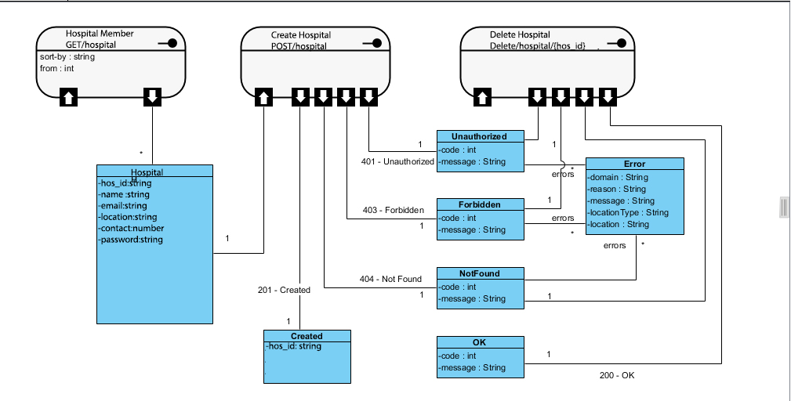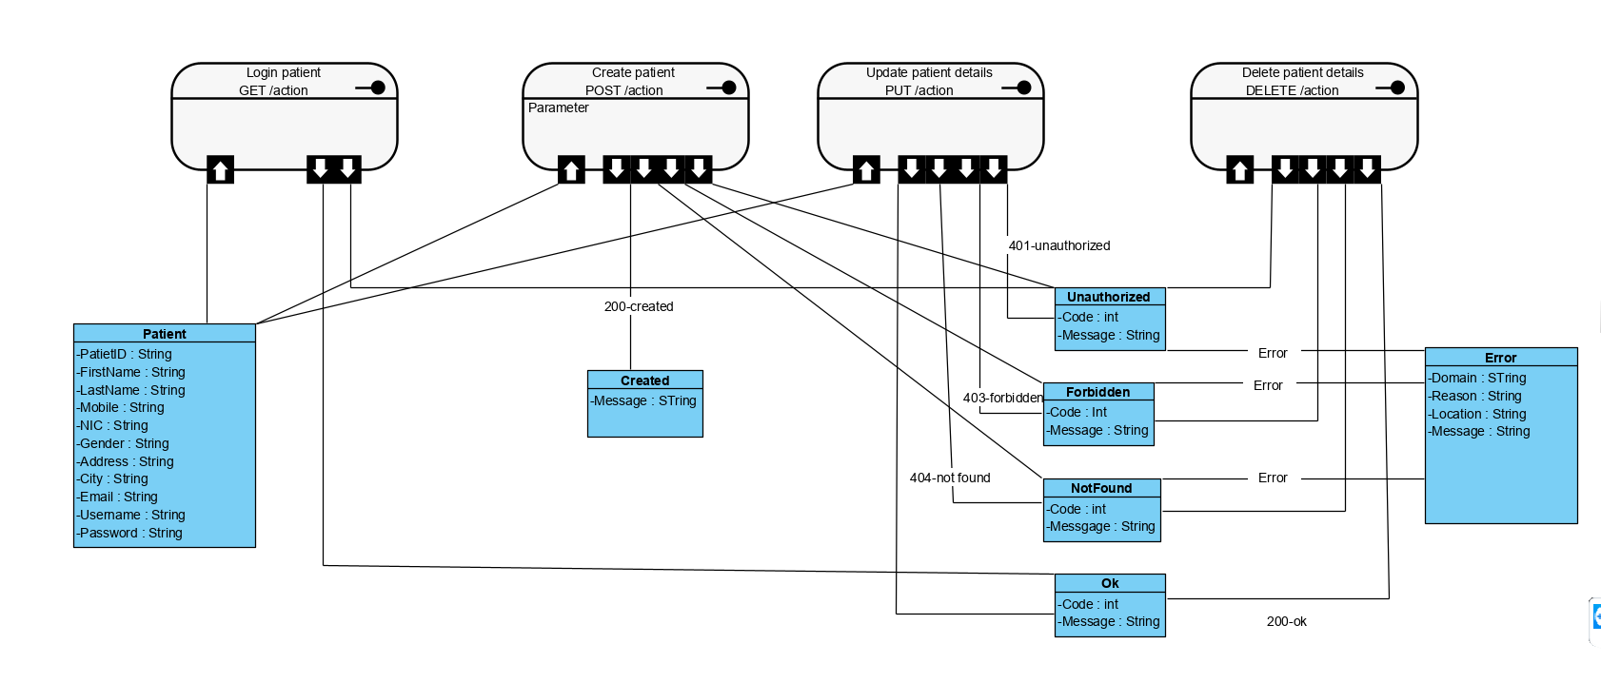

Appendixes

***Appendix 1 – ER Diagram***

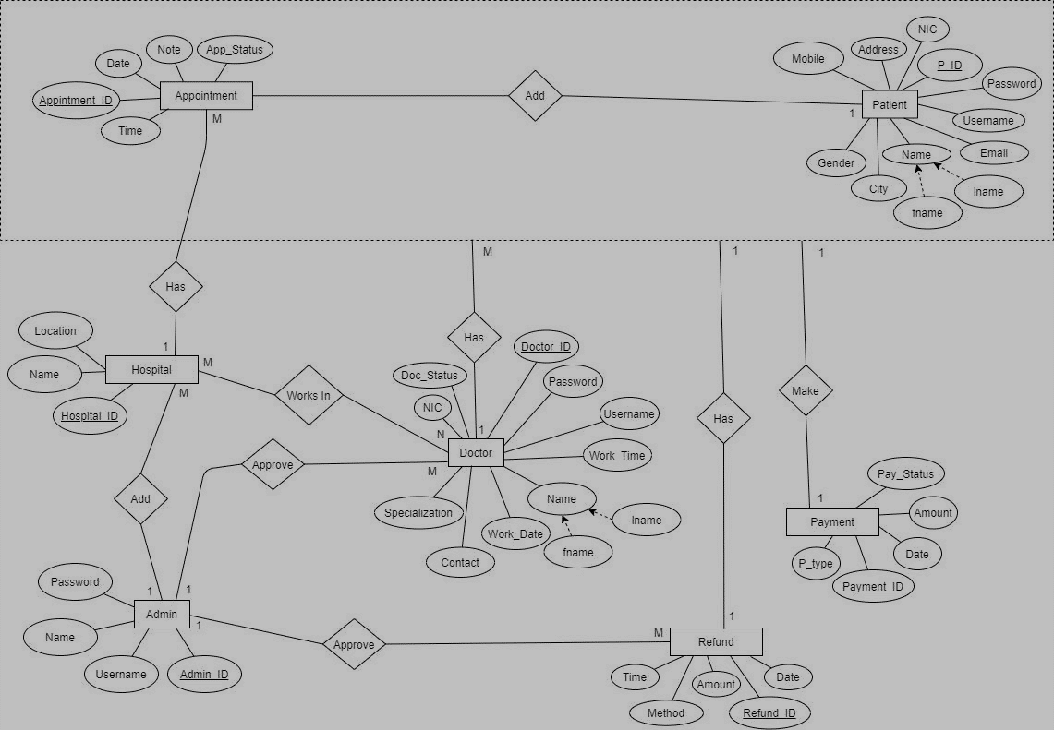

***Appendix 2 –Schema***

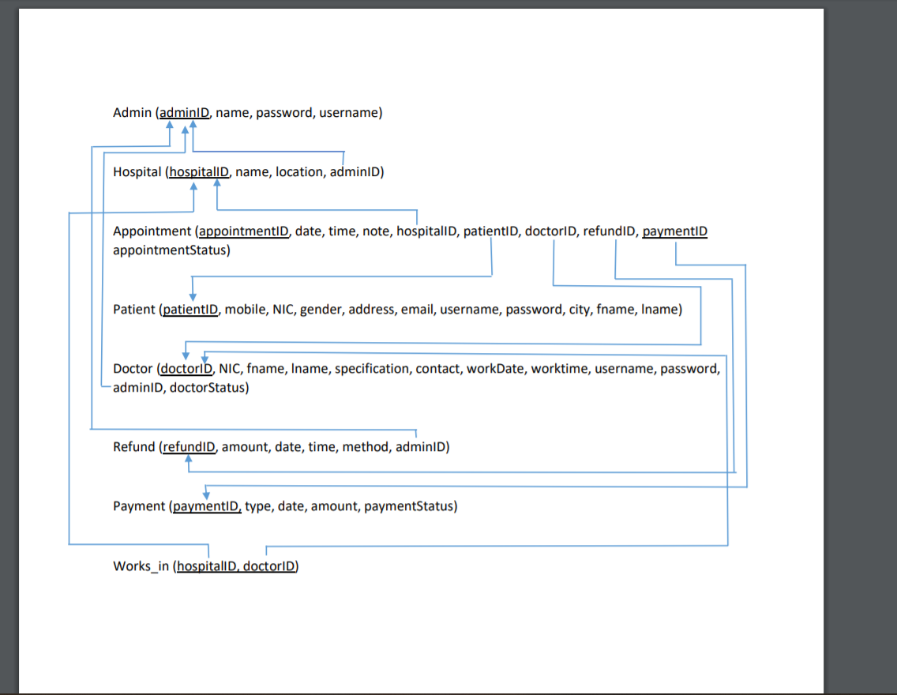

***Appendix 3 – Use case diagram***

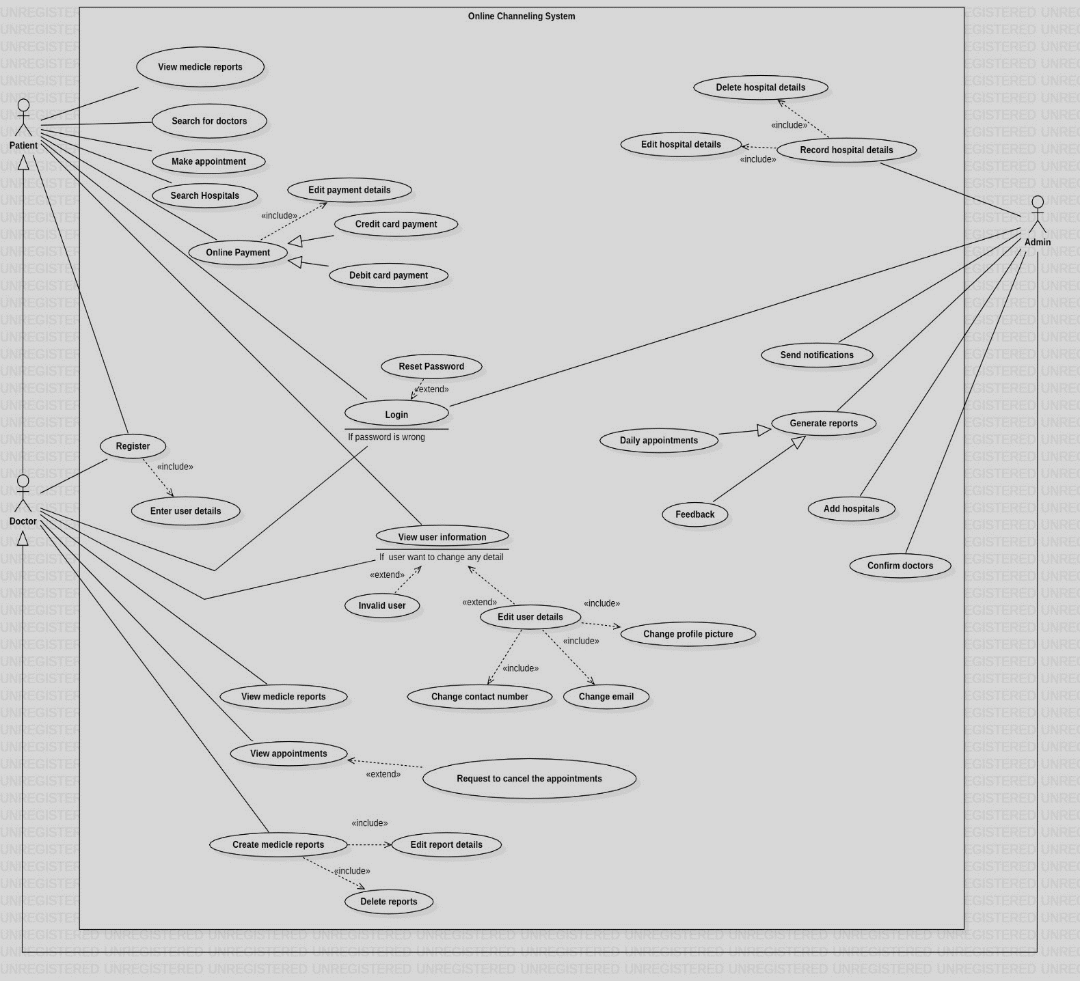

***Appendix 4 – Overall Architecture***

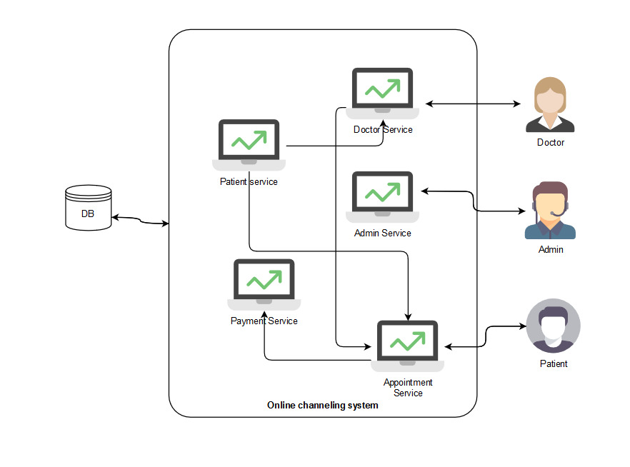

***Appendix 5 - Class Diagram***

